SUMMATIVE #1- answers
1
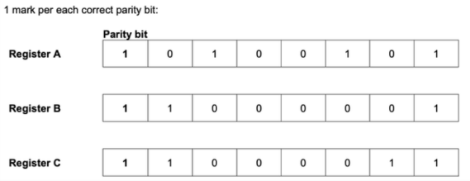
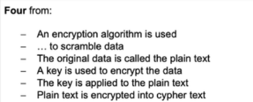
2
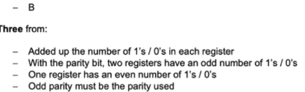

3 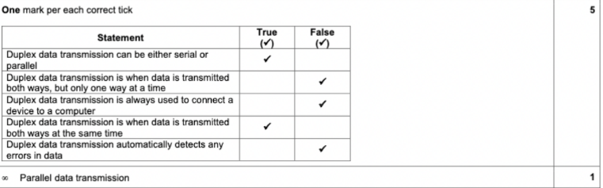

4 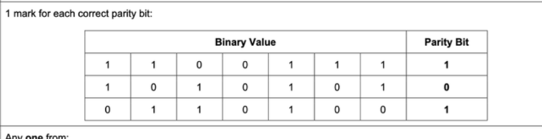
5
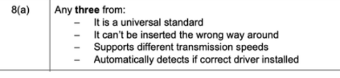
6
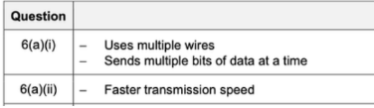
7
8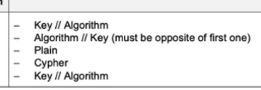

9
Automatic repeat request (ARQ) → "An error detection method that uses response and time out when transmitting data; if a response is not sent back to the sender in an agreed amount of time, then the data is re-sent."
Data Transmission: The sender transmits a data packet to the receiver.
Error Checking: The receiver checks the received data using error detection techniques like checksums or parity bits.
Acknowledgment (ACK) or Negative Acknowledgment (NACK):
- If the data is received correctly, the receiver sends an ACK (Acknowledgment) to confirm successful reception.
- If an error is detected, the receiver sends a NACK (Negative Acknowledgment) or does not respond at all.
Retransmission: If the sender receives a NACK or does not receive an acknowledgment within a specific timeout period, it retransmits the data packet.
Process Repeats: This process continues until the receiver successfully receives the correct data and sends an acknowledgment.

10

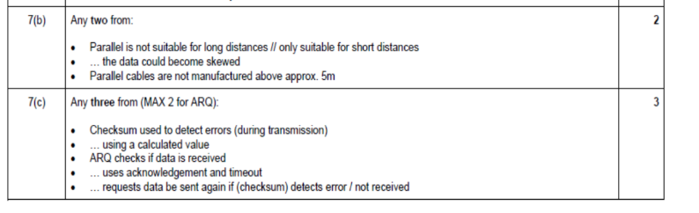
11

Parity Check:
A parity bit is added to a group of bits to make the total number of 1s either even (even parity) or odd (odd parity). The receiver checks the parity bit to determine if an error has occurred during transmission. If the parity does not match the expected value, the receiver knows an error has occurred.
Check Digit:
A check digit is an extra digit added at the end of a numeric value (e.g., barcode or ISBN) and is calculated using a mathematical formula based on the other digits. The receiver recalculates the check digit upon reception to verify if the data has been transmitted correctly.
Checksum:
A checksum is a value computed from a block of data using an algorithm. The sender transmits the data along with the checksum, and the receiver recalculates the checksum. If the calculated checksum does not match the received one, an error is detected.
Automatic Repeat reQuest (ARQ):
ARQ is an error correction method where the receiver checks for errors in received data. If an error is detected, the receiver requests the sender to retransmit the data. If no acknowledgment (ACK) is received within a timeout period, the sender resends the data until it is correctly received.

12

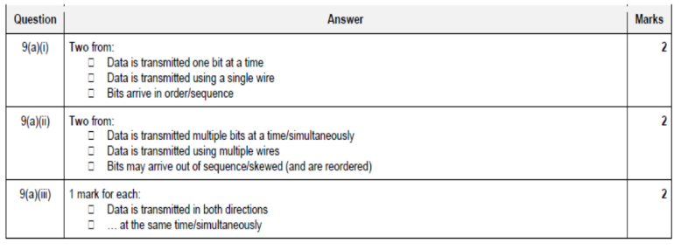

13
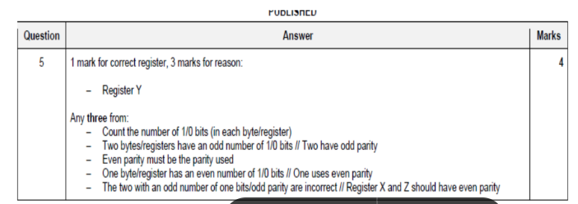
14 same as below

SUMMATIVE #2- answers
1
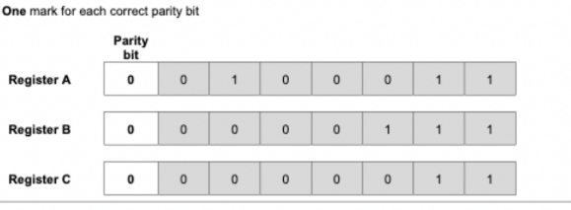
2
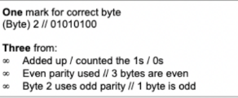
3 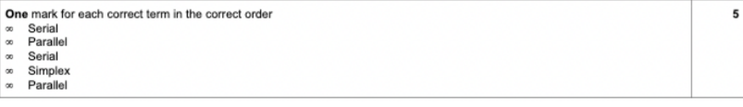
4
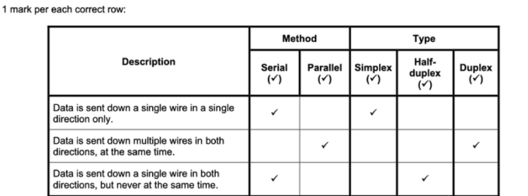
6
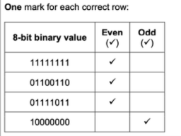
8
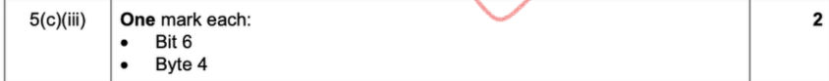
9
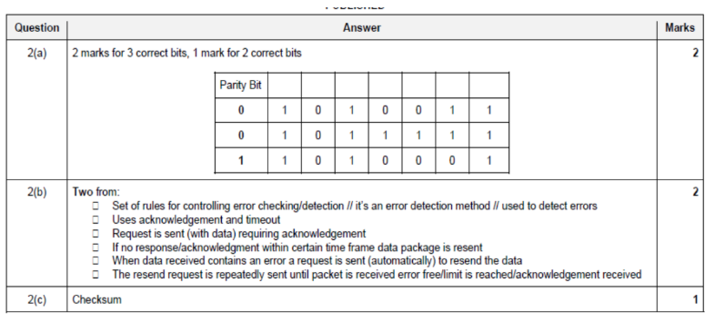
10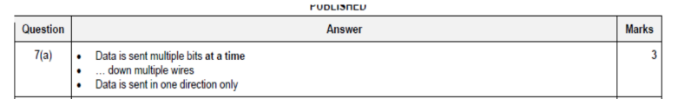
11
????
12
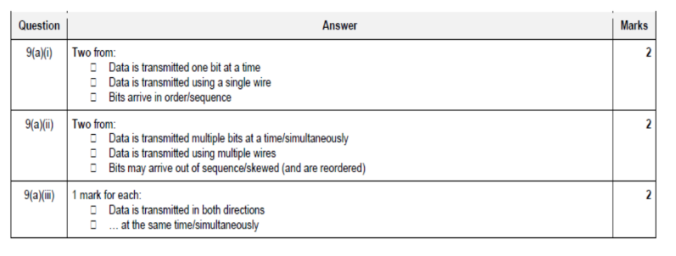
13
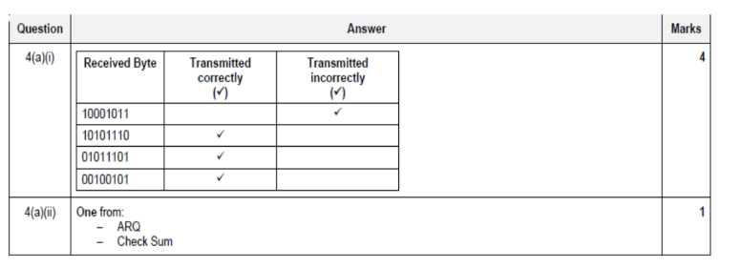

14
Serial, simplex data transmission → "One bit sent at a time, over a single wire in one direction only."
Parallel, half-duplex data transmission → "Several bits of data sent down several wires, in both directions, but not at the same time."
Parity check → "An even or odd number of bits set to 1 in a byte, used to check if the byte has been transmitted correctly."
Automatic repeat request (ARQ) → "An error detection method that uses response and time out when transmitting data; if a response is not sent back to the sender in an agreed amount of time, then the data is re-sent."
Checksum → "A value transmitted at the end of a block of data; it is calculated using the other elements in the data stream and is used to check for transmission errors."

